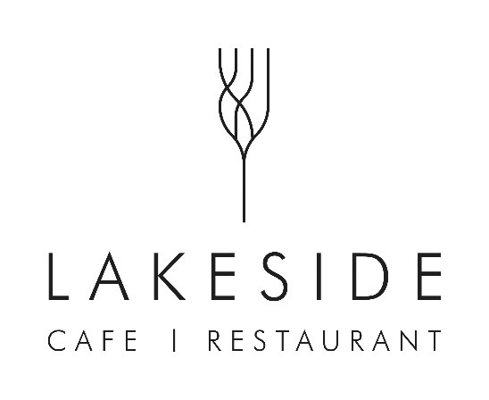

BRUNCH
Available 10am to 4:30pm
BRIOCHE BREAKFAST BUN | 6 – A choice of
Cumbrian Home Cured Back Bacon or Cumberland Sausage
Add a Fried Egg | 2

CHIMICHURRI MUSHROOM WRAP | 6
Vegan Cream Cheese, Dry Aged Tomatoes, Rocket

JACKET POTATO | 6.95
A choice of Tuna Crunch or Cheddar, served with a side salad

BOWL
Available 10am to 7pm
SOUP OF THE DAY | 5.50
Served with Sourdough. Please ask your server for today’s flavour

ROAST SALMON | 10.50
Puy Lentils, Root Vegetables, Olive Oil Mash

CHANA DRAMA | 9.50
Sweet Potato and Chickpea Curry, Toasted Pumpkin Seeds, Pickled Red Onions, Watercress, Flatbread

CAMPFIRE CASSOULET | 9.50
Slow Cooked Eden Valley Pepper Pot Sausage & Borlotti Bean Cassoulet,
Grilled Goat’s Cheese, Flatbread

HERDWICK LAMB RAGU | 11.50
Braised Herdwick Lamb, Cumbrian chorizo, Pappardelle, Parmesan, Lovingly Artisan Focaccia

CRUST
Available 10am to 7pm
BBQ JACKFRUIT | 10
BBQ Pulled Jackfruit, Beetroot Hummus, Pickled Red Onions,
Mixed Leaves, Khobez Flatbread

HERDWICK LAMB SHARWARMA | 12
Spiced Herdwick Lamb, Beetroot Hummus, Pickled Red Onions, Mint Yoghurt,
Mixed Leaves, Khobez Flatbread

LAKESIDE BURGER | 12
Garlic and Thyme Grilled Chicken, Appleby Cheddar, Onion Marmalade, Pickled Slaw,
Rocket, Brioche

SKINNY FRIES | 3.50
CAKES, SCONES
&
SPECIALS
Please ask a
member of
staff for
todays
choices

